Home Learning activities and links
EYFS/KS1/KS2 | March/April 2020

A collection of links to activities, resources, live lessons and fun ideas to help keep your children entertained and educated during the school closures.
General resource sites for all ages and subjects:
https://www.twinkl.co.uk/ -
A huge range of teaching resources, stories, powerpints, interactive activities and printable worksheets for EYFS, KS1 and KS2. http://twinkl.co.uk/offer. Click this. Then either sign up or Enter your username and password and enter this offer code: PARENTSTWINKLHELPS
http://www.primaryresources.co.uk/
Free teaching resources for all ages across most subjects.
https://www.teachingideas.co.uk/
Free teaching resources for all ages across most subjects.
https://home.oxfordowl.co.uk/
Free resources to support learning at home – Reading, English and Maths. Advice and support for parents - Educational activities and games - Free eBook library for 3- to 11-year-olds
https://ed.ted.com/daily_newsletter
To support the millions of students, parents and teachers affected by the COVID-19 pandemic, TED-Ed is working with expert educators and TED speakers throughout the world to create and share high-quality, interactive, video-based lessons on a daily basis, for free.

Fun activities and ideas for all ages:
https://selfsufficientkids.com/indoor-activities-for-kids-rainy-day/
http://whatshallwedo.co.uk/things-to-do-at-home/
Random idea generator for fun things to do around the home
https://www.orchardtoys.com/dept/things-to-do_d0127.htm
https://theimaginationtree.com/stay-at-home-survival-guide/ -
popular teacher-run blog filled with fun ideas and resources
https://www.woojr.com/
Lots of ideas and printable activities for EYFS to UKS2 (American site)

Daily activities and challenges:
Here's what various celebrities are offering you and your children daily to help with their education if schools are closed:
9.00am - PE with Joe Wicks https://youtu.be/6v-a_dpwhro
10.00am - Maths with Carol Vorderman www.themathsfactor.com
11.00am - English with David Walliams https://www.worldofdavidwalliams.com/elevenses/
12.00pm - Lunch (cooking with Jamie Oliver) https://www.jamieoliver.com/.../category/get-kids-cooking/
1.00pm - Music with Myleene Klass https://www.youtube.com/channel/UCQh2wgJ5tOrixYBn6jFXsXQ
1.30pm - Dance with Darcey Bussel https://twitter.com/diversedan.../status/1241098264373592065
2.00pm - History with Dan Snow (free for 30-days) https://tv.historyhit.com/signup/package
4.00pm - Home Economics with Theo Michaels (Mon/Wed/Fri) https://www.instagram.com/theocooks
Please note that these links initially take the user to a site via Facebook, although no log in to Facebook is involved. Children may therefore require supervision when accessing these links.
Non-daily events include:
Science with Professor Brian Cox, Robin Ince & Guests https://cosmicshambles.com/stayathome/upcoming-schedule
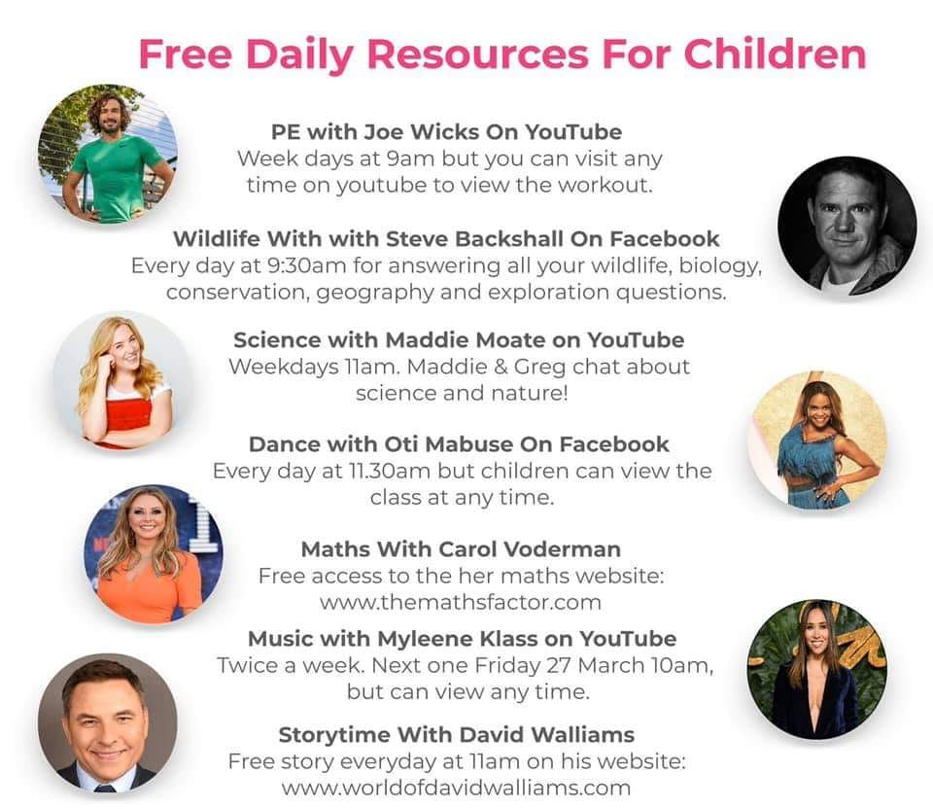

Wellbeing/Physical Education:
https://www.gonoodle.com/
GoNoodle® gets kids up and moving to fun, engaging content and games. Every dance party, yoga session, mindfulness activity, and game session is an opportunity for kids to wake up their bodies, engage their minds, and be their best.
https://www.healthforkids.co.uk/
Health for Kids introduces a new and different way for primary school children to learn about their health
All the content has been produced by our health experts, often re-written from other trusted NHS information such as NHS Choices. The website is primarily a health promotion website, covering subjects that promote a healthy body and mind. It is not about managing serious illnesses for which more specialist websites already exist.

https://www.youtube.com/user/CosmicKidsYoga
Fun stories and yoga
Literacy, books and video books:
https://www.youtube.com/channel/UC7sW4j8p7k9D_qRRMUsGqyw
Mr. T’s phonics channel: Mr Thorne is a UK teacher publishing apps, Youtube videos and creating educational content to help anyone learn to read.
https://www.teachyourmonstertoread.com/
The groundbreaking game that makes learning to read fun • Covers everything from letters and sounds to reading full sentences. • Designed in collaboration with leading academics. • Complements all synthetic phonics programmes used in schools. • Computer version is 100% free.
https://www.seussville.com/ - a range of activities and games based on the works of Dr. Seuss.
https://radioblogging.net/index.php/welcome-to-radioblogging-net/
Welcome to RadioBlogging – daily shows with interactive activities to keep everyone busy and engaged, brought to you by Pie Corbett, Deputy Mitchell, Ian Rockey and Russell Prue, just listen and blog, it’s live, fun and interactive with new educational tasks each day for your students whether at home or in school.
https://www.storylineonline.net/ (Fantastic American resources)
Storyline Online, streams videos featuring celebrated actors reading children’s books alongside creatively produced illustrations. Readers include Viola Davis, Chris Pine, Lily Tomlin, Kevin Costner, Annette Bening, James Earl Jones, Betty White and dozens more.
Each book includes supplemental curriculum developed by a credentialed elementary educator, aiming to strengthen comprehension and verbal and written skills for English-language learners.
https://stories.audible.com/start-listen
Free for 30 days (charges apply after this time). “Kids everywhere can instantly stream an incredible collection of stories, including titles across six different languages, that will help them continue dreaming, learning, and just being kids. All stories are free to stream on your desktop, laptop, phone or tablet. Explore the collection, select a title and start listening. It's that easy.”
Mathematics:
https://whiterosemaths.com/
Always happy to help, the White Rose Maths Team has prepared a series of five maths lessons for each year group from EYFS-Year 8. Every lesson comes with a short video showing you clearly and simply how to help your child to complete the activity successfully.
https://www.themathsfactor.com/
Carol Vorderman is offering FREE subscriptions to her maths site during school closures. Visit the website to see how to sign up.
https://masterthecurriculum.co.uk/membership/
Some free maths resources available when you sign up.
https://diagnosticquestions.com/WhiteRose
We are very proud to have partnered with White Rose to bring you two lovely quizzes for each topic unit for their Years 1 to 8 maths mastery schemes of work.
https://corbettmathsprimary.com/
5-a-day, Videos, Workshops, Quizzes
https://www.piximaths.co.uk/
Key stage 2-Key Stage 4 maths resources
Art and Design/D&T/Music:
https://thatbricklife.com/
Lego-based activities with challenges for all ages
https://www.bbc.co.uk/teach/bring-the-noise
BBC’s music page with resources and activities for all key stages
https://www.youtube.com/channel/UCHRHILY0t3i5VvKEeFMoJxw
Cartoon drawing tutorials by Steve Harper
https://www.steviedoodles.com/
Unique colouring pages to download and print
https://www.youtube.com/channel/UC6Shlu98MRG-MLpZpxGGxuA
YouTube-based art lessons designed for children

Science/History/Geography:
https://www.natgeokids.com/uk/
https://www.dkfindout.com/uk/
https://learningscience.co.uk/blog/2018/7/5/wow-science-a-new-child-friendly-primary-science-website

Languages:
https://www.rosettastone.com/freeforstudents/
Free 3 month subscription to this online language service.
ICT/Coding:
https://scratch.mit.edu/
With Scratch, you can program your own interactive stories, games, and animations — and share your creations with others in the online community.
https://www.scratchjr.org/
For ages 5-7
https://codakid.com/
https://www.tynker.com/

Outdoor learning:
https://www.woodlandtrust.org.uk/blog/2020/03/kids-nature-activities-self-isolation/?fbclid=IwAR0U_cCBtbOab8WGBjROfEcAZnABENCMFTCiRNOivYRKwJ1TpOCX4NPmWBE 10 nature activities for kids if you're self-isolating at home
https://outdoorfamiliesonline.com/rewilding-challenge-activity-calendar-printable/

