Year 2 Summer 2 RSHE – We meet God’s love in the community
Social, emotional, physical and spiritual development learning intention | Key Vocabulary | What am I learning?
I can recognise the joy and friendship of belonging to a diverse community  I can describe ways of being safe in communities  I can celebrate ways of meeting God in our communities | Harm: when we are in danger of being hurt, physically or emotionally.  Secrets: something that we don’t tell others.  Respect: treating others in a positive way.  Equal: the same  Safety: how we keep ourselves from being hurt, physically or emotionally. | Aim: To describe how we are growing and developing in diverse communities that are God-given.  What makes us feel safe in our families, in our friendships and in our wider communities.  What could make you feel unsafe and when is it not right to keep a secret.  Who I can go to if I feel worried about another person who you think is unsafe.  Knowing how to ask for help and who we should talk to.  How we can keep safe when we use the internet and digital devices.  Online safety – knowing what is true and how we can check.  What are the things harming our world and how we can try and stop them.  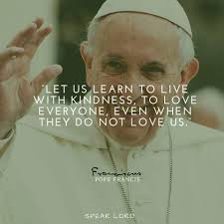
Key questions | Key skills
How would you describe your community?  How do different individuals enrich our communities?  What makes us feel safe in our families and wider communities?  Do you know how to ask for help?  How does the school mission statement celebrate our community? | Listening  Describing  Recognising  Informing  Forgiving  Sharing  Speaking  Respecting  Observing  Praying  Relating  Celebrating  Creating  Reflecting  Supporting  Deciding

