Year 2 Autumn 2 2020
Learning objectives for this topic | Key vocabulary | Useful websites to search for
To recognise sequences of long & short sounds – listening.  To recognise duration, pulse & rhythms.  To find their singing voice  To sing collectively at the same pitch  To learn songs for Christmas.  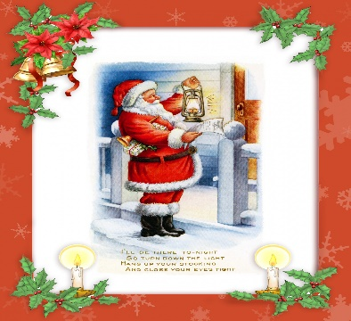 | Duration – length of note/sound.  Pulse – the heartbeat of the music  Beat – another name for pulse  Rhythm – a repeated sequence of beats  Pitch – how high or low a sound is. This can be on a tuned instrument or with our voice.  Percussion – an un-tuned instrument used to accompany music.  Glockenspiel – a tuned instrument which is played by striking the metal bars with a beater. | BBC Learning Zone
 |  | Christmas songs
