EYFS Summer 2 RSHE –The wonder of being special and unique
Social, emotional, physical and spiritual development learning intention | Key Vocabulary | Info
I know that we are special and unique  I can recognise the joy of being a special person in my family  I can celebrate the joy of being a special person in God’s family | God  Wonder  Love  Hands  Fingers  Nails  Faces  Noses  Lips  Hair  Features  Colour  Shape  Size  Unique  Belonging  Different  Special  Describe  Friends  Generous  Worried  Baptism | Possible activities  Draw and name each person in your family  Design a ‘thank you’ card thanking God for creating us.  Create a family tree  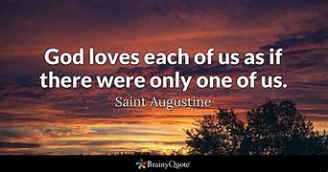
Key questions | Key skills
Why are you special in your family?  How do you know that you are special in your family?  How does God show love to you and your family?  Look at me. How am I different to you?  Why has God made us all different and special to him?  How do we celebrate with each other?  How can we celebrate being a special part of God’s family? | Listening  Sharing  Speaking  Respecting  Observing  Praying  Relating  Celebrating  creating

