Learning Objectives | Skills
- Perform a variety of more advanced actions, balances and body shapes accurately with emphasis on extension and control.  - Perform skills learnt precisely with confidence on both floor and large apparatus.  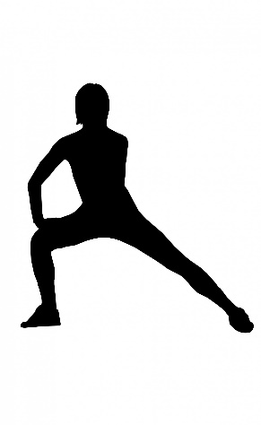  - Work with body tension and extension.  - Show awareness of each other, the mats, and the equipment/apparatus. | Symmetrical body shapes  Asymmetrical body shapes  Partner balances – counter tension  Partner balances – counter balance
 | Key Vocabulary
Symmetrical
Asymmetrical
Counter balance
Counter tension
Contrasting
Compose
Forces

