Year 6 Spring 1 Exploring the Mass
Key Stories | Key Bible Passages | Key Vocabulary
The miracle of the loaves  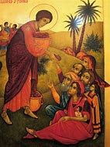  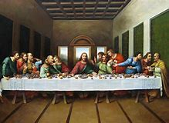  The Last Supper  The Rich man and Lazarus  The Miracles of Jesus  The Mass  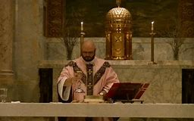 | The last Supper  Jn 6: 35 I am the bread of life  Jn 6: 1-14 The miracle of the loaves  Jn 13:34 The New Commandment  Jn 14:1 Jn 14:14-15 Lk 6:27 Isiah43:4 Col 3:12 quotations | Unleavened bread, memorial, Sacramental sign, New Covenant, concentration camp  Proclaim, fellowship, Exodus, omission  host, hallowed, trespasses, appearance, reverence, crucifix  genuflect Monstrance Sanctuary Lamp Tabernacle
 | Key Colours
 | Green – Ordinary Time
 | White or Gold- Christmas and Easter
 | Red – Celebrations and feast days
 | Purple – Advent and Lent
 | Key Ideas | Key Figures/ People
 | - Know that Jesus is the bread of life and think about what this means for us  - Understand that Jesus made a new covenant with us.  - Understand the Penitential Rite and The Liturgy of The Word and reflect on our participation in them.  - Understand what happens at the offertory and think about the offerings we can make.  - To know what happens at the consecration and what this means for us  - Know that it is Jesus we receive in Holy Communion and be aware of how important this is for us.  - Understand that The Eucharist is the source and summit of life. Reflect on its importance for us. | Jesus  Ourselves  Blessed Chiara Bandano

