Year 5 French Autumn 1 2021
Learning objectives for this topic | Key vocabulary | Useful websites
To learn food vocabulary in coherent groups: fruit, vegetables, meat, cheese.  To learn the meals vocabulalry  To learn how to say what food you like or dislike, and to classify foods according to their healthy or unhealthy qualities  To read and understand a recipe.  To write a recipe  To be able to talk about musical instruments.  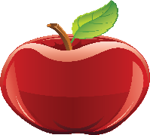  Pomme gateau  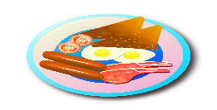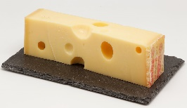  Petit dejeuner fromage | Food  Apple = pomme  Banana = banane  Pear = poire  Strawberry = fraise  Orange juice = jus d’ orange  Sandwich = sandwich  Pizza = pizza  Cake = gâteau  Ice cream = glace  Cheese = fromage  Potato = pomme de terre  Carrot = carrotte  Meals  Breakfast = petit dejeuner  Lunch = dejeuner  Supper = souper  Musical Instruments  Piano = piano  Guitar = guitare  Trumpet = trompette  Tambourine = tambour | BBC Learning Zone
 |  | Numbers
11 = onze
12 = douze
13 = treize
14 = quatorze
15 = quinze
16 = seize
17 = dix-sept
18 = dix-huit
19 = dix-neuf
20 = vingt
30 = trente
40 = quarante
50 = cinqante
60 = soixante
70 = soixante-dix
80 = quatre-vingts
90 = quatre-vingt-dix
100 = cent

