Learning Objectives | Key Vocabulary
- Demonstrate the ability to run at different speeds.  - Know the difference between sprinting and running.  - Understand the principles of relay races.  - Jump with accuracy and good technique.  - Throw with accuracy and power at targets of different distances.  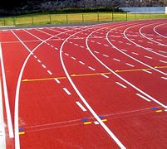  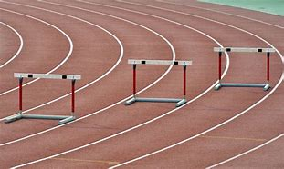  - Gain an understanding of the variety of jumps involved in Athletics. | Steeplechase  Speed bounce  Long jump  Triple jump | Javelin  Shot putt  Discus  Personal best
 | Skills
 | Sprint  Run  Jump  Balance  Combination jumps | Land  Javelin throw  Sling technique  Push technique  Take-off

