Year 1 Spring 1 PSHE – Dreams and Goals
Learning objectives  PSHE Learning Intention | Key Vocabulary | Info
I know how to use my Jigsaw Journal  I understand the rights and responsibilities as a member of my class  I understand the rights and responsibilities for being a member of my class  I know my views are valued and can contribute to the Learning Charter  I can recognise the choices I make and understand the consequences  I understand my rights and responsibilities within our Learning Charter | Safe  Special  Calm  Rights  Responsibilities  Rewards/Consequences  Proud | This unit has a strong focus on the class getting to know each other and bonding. This unit develops skills and a sense of pride and achievement. It provides the children to showcase their work and their achievements over the half term.  Pieces:  - Special and Safe  - My Class  - Right and Responsibilities  - Rewards and Feeling Proud  - Consequences  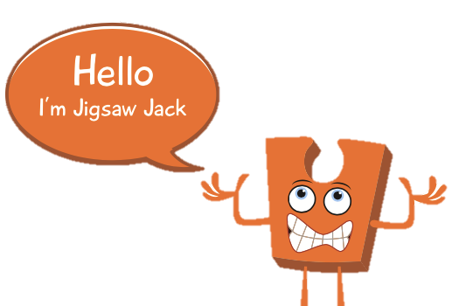  - Owning our Learning Charter.
Social and emotional development learning intention | Activities, books and songs
I feel special and safe in my class  I know that I belong to my class  I know how to make my class a safe place for everybody to learn  I recognise how it feels to be proud of an achievement  I recognise the range of feelings when I face certain consequences  I understand my choices in following the Learning Charter | Books  Super Duper You!  When I grow up  The Most Magnificent Thing  Songs  Together As One  Activities  Create Gingerbread People, that all connect together to show that the class are ‘together as one’.

