Year 2 - Spring 1 - PSHE – Dreams and Goals
Learning objectives  PSHE Learning Intention | Key Vocabulary  Team work  Celebrate  Challenge  Feelings  Overcome  Achieve | Info
I can choose a realistic goal and think about how to achieve it  I carry on trying (persevering) even when I find things difficult  I can recognise who I work well with and who it is more difficult for me to work with  I can work well in a group  I can tell you some ways I worked well with my group  I know how to share success with other people | Proud  Success  Achievement  Goal  Treasure  Dreams  Progress | This unit has a strong focus on inspiring children to set goals for their future. This unit supports children in developing lifelong skills that support children to achieve their goals.  Pieces:  - Goals to Success  - My Learning Strengths  - Learning with Others  - A Group Challenge  - Continuing Group Challenge  - Celebrating Our Achievement  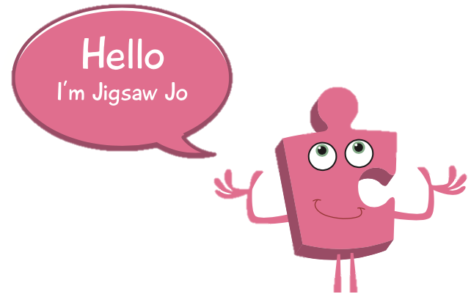
Social and emotional development learning intention | Activities, books and songs
I can tell you things I have achieved and say how that makes me feel  I can tell you some of my strengths as a learner  I can tell you how working with other people helps me learn  I can work with others in a group to solve problems  I can tell you how I felt about working in my group  I can tell you how being part of a successful group feels and I can store these feelings in my internal treasure chest | Books  What We’ll Build  The Lion Inside  Songs  For Me  All things bright and beautiful  Activities  Learn a new dance/song  Count to 10 in French  Learn how to say ‘good morning’ or ‘good afternoon’ in a new language.

