Year 3 Autumn 1 Computing- Computer Skills and Word Processing
Learning objectives | Key vocabulary | Useful websites to search for
Use technology purposefully to manipulate and retrieve digital content.  Use technology purposefully to create, organise, store, manipulate and retrieve digital content.  Recognise common uses of information technology beyond school  Select, use and combine a variety of software (including internet services) on a range of digital devices to design and create a range of programs, systems and content that accomplish given goals, including collecting, analysing, evaluating and presenting data and information. | 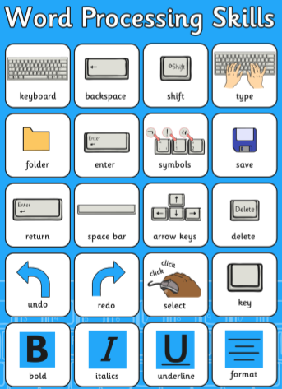 | - KS2 Computing BBC Bitesize  - The School Run KS2 Computing
 |  | 