Year 3 Summer 1 Art - Art and Design Skills
Learning objectives | Key vocabulary | Useful websites to search for
To draw cartoon characters, inspired by the style of other artists.  I know that Carl Giles is a cartoonist  I can talk about the key features of a piece of art.  I can draw my family in a minimalist, graphical/cartoon style.  I can give each character in my drawing a distinctive feature to identify them.  I can compare the style of my work to the work of other artists. | Cartoonist An artist who makes a series of drawings or illustrations.  Character A description of a person.  Minimal A very simple design without many colours.  Opaque A solid surface that you cannot see through.  Puppet A doll moved by strings or your hand.  Sketching A fast, light drawing that is often made as a p[an for a drawing or painting.  Style The way in which something has been drawn.  Three dimensional A solid object, with width length and height.  Tint The adding of white to make a colour lighter.  Tone The lightness and darkness of a colour. | - How to Draw for Kids | Very Easy Drawing Lessons for Kids  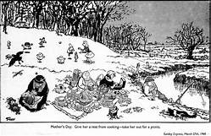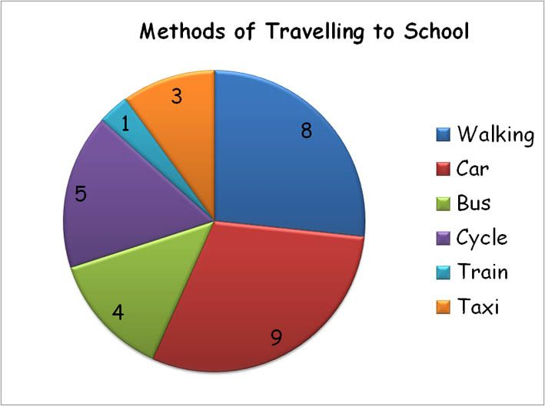
 |  | 