Year 2 Summer 2 History
Learning objectives for this topic | Key vocabulary | Useful websites to search for
To understand how transport has changed over time.  How do we travel from place to place now?  What was transport like when my great grandparents were alive?  What will it be like in the future, when you have children of your own?  To learn about the development of the car over time.  To learn about the development of flight over time.  To understand when space travel started and begin to develop a chronology of space exploration.  To recognise the significance of the moon landings in 1969. | Transport – how people or goods travel from place to place. To move something from one place to another.  Chronological – events in time order.  Past – the time before this moment.  Future – time that is still to come. Something that hasn’t happened yet.  Modes of transport – trains, cars, buses, aeroplanes, walking, horse and cart, hot air balloon, bicycle.  Automobile – car  Invention – something that has been created or designed.  Travel – go from one place to another. | www.ltmuseum.co.uk  www.sciencemuseum.org.uk  www.britishpathe.com  www.bbc.co.uk
 |  | Key People
 |  | 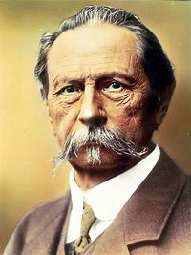  Karl Benz – inventor of the first car. | 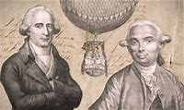  Montgolfier brothers – invented the first air balloon
 |  | 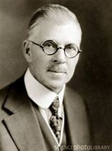  Ransome E Olds – invented the Oldsmobile | 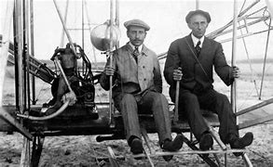  Wright brothers – the first people to fly a machine
 |  | 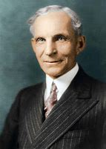  Henry Ford – began Ford cars | 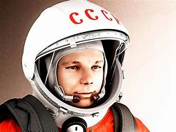  Yuri Gargarin – the first human to go to space
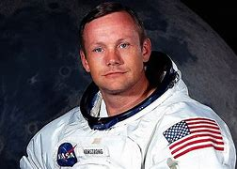
Neil Armstrong – the
first man to walk on
the moon.

