Aut 1 God’s Wonderful World
Key Stories |  | Key Bible Passages |  | Key Vocabulary
Creation  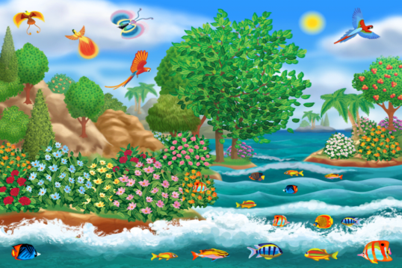  God loves Us  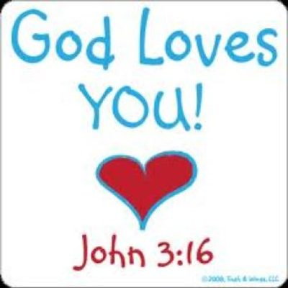 |  | That power of creation is expressed in the Book of  Genesis in the words: ‘Let there be light’, and there was light.  God made us all out of His great and personal love for each  one of us. Each one is special and different from others.  Indeed, God calls each of us by name, each one of us is  precious to God:  “Do not be afraid, for I have redeemed you;  I have called you by your name, you are mine” (Isaiah 47:1). |  | Creation | Plants/Animals
 |  | Stories-Dear Zoo, All about me, Guess how much I love you? |  | Love | Prayers
 |  | Key Colours |  | World | Pray
 |  | Green – Ordinary Time |  | Light | Reflect
 |  | White or Gold- Christmas and Easter
 |  | Red – Celebrations and feast days
 |  | Purple – Advent and Lent
 |  | Key Ideas |  | Key Figures/ People
 |  | Children begin to hear about God’s wonderful world. |  | God
 |  | Learn about animals in God’s world.  Reflect on the animals God made for us. |  | Jesus
 |  | Know that God made us.  Be aware that we are unique.  Understand that God loves each one of us always.  To learn about God being in every home and family, and God’s care for each person in the family. |  | Songs  He’s got the whole world in his hands  If I were a butterfly.  123 it’s good to be me.

