Learning Objectives | Key Vocabulary
- Demonstrate strength, stamina and speed when running and understand how to manage pace effectively.  - Change-over efficiently with the baton at high speeds during relays.  - Jump with strength, balance and speed throughout all stages of the jump.  - Throw with excellent accuracy, power, speed and strength using run-up in javelin.  - Aim to achieve personal bests in all events.  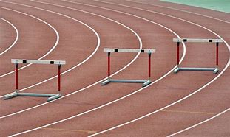  - Organise and manage an athletics event using knowledge and understanding gained. | Steeplechase  Speed bounce  Long jump  Triple jump  Javelin  Shot putt  Discus  Personal best  Obstacle  Combination  Control  Timing  Release | Distance  Changeover  Flight  Stride  Technique  Push throw  Pull throw  Efficiency  Tempo  Pace  Stamina  Endurance
 | Skills
 | Sprint  Run  Jump  Balance  Combination jumps |  | Land  Three stride run-up  Javelin throw  Sling technique  Push technique

