Learning Objectives | Skills
- Learn how to hold the hockey stick correctly whilst maintaining the correct posture.  - Develop dribbling skills including stopping the ball and making a bridge to change direction).  - Understand basic passing techniques and develop passing skills using the push pass effectively.  - Develop receiving skills by making a barrier to receive a pass.  - Develop tackling skills using block and jab tackles effectively.  - Find and use space and communicate with teammates.  - Choose positions in their team.  - Know how to mark and defend the goals.  - Play small-sided games effectively.  - Use a variety of tactics to keep the ball from the opponent.  - Understand different ways to get the ball to the opponent’s goal.  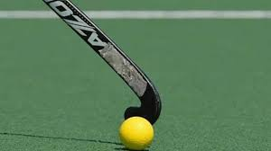 | Warm-up  Dribble  Receive and control  Jab tackle  Block tackle  Bridge  Push pass  Shoot | Defend  Positional play
 | Key Vocabulary
 | SAFETY  GRIP  FLAT-SIDE  BRIDGE  INVASION  PUSH PASS  BARRIER  ATTACKING  DEFENDING | JAB  BLOCK  RECEIVING  SENDING  TACKLE  COMMUNICATE  POSSESSION  POSITIONING  EFFECTIVELY

