Learning Objectives | Skills
- Demonstrate strength, stamina and management of speed when running whilst handling the ball.  - Apply dodging and evasion appropriately within the game.  - Throw with excellent accuracy, power, speed and strength while running and standing still.  - Use the ‘W’ handling technique when catching the ball.  - Use knowledge and understanding to confidently select passing, positioning, running spaces and speeds within the game.  - Appropriately use correct and specific movements during the game.  - Use spatial awareness and communication to attack and defend effectively.  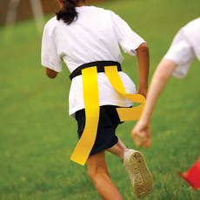 | Warm-up  Handling  ‘W-shape’ handling  Catch  Pocket pass  Dodge  Evasion | Tagging  Tackle  Score  Attack  Defend  Interception
 | Key Vocabulary
 | Passing  Catching  Tagging  Forwards  Backwards  Sideways  Invasion  Try  Handling  Spatial-awareness  Knock-On | Attacking  Defending  Accuracy  Teamwork  Intercept  Tactics  Assist  Technique  Overload  Possession  Utilise

