Learning Objectives | Key Vocabulary
- Throw a ball accurately using the underarm throwing technique.  - Use the correct technique to catch a ball using hands in a bucket shape.  - Use a good technique to grip the bat and know how to stand when receiving the ball.  - Understand when to use the appropriate throwing technique (underarm/overarm)  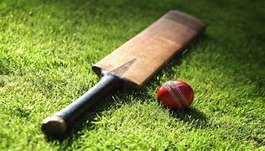  - Consistently make contact with the ball when attempting to strike it with a cricket bat. | Batting  Fielding  Wickets  Bowling  Target | Retrieve  Grip  Stance  Wide  Boundary
 | Skills
- Catching
- Fielding
- Overarm bowling
- Throwing
- Combination batting
- Backswing
- Wicket keeping

