Learning Objectives | Key Vocabulary
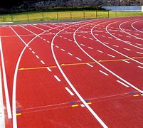  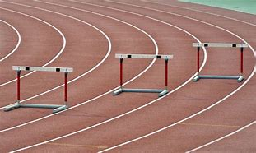  - Demonstrate a good technique when sprinting and increase the distance when running.  - Use the correct technique when changing over the baton in relays.  - Demonstrate good techniques for take-off and landing when jumping.  - Use the appropriate throwing techniques for different events (shot, discus and javelin). | Steeplechase  Speed bounce  Long jump  Triple jump  Javelin  Shot putt | Discus  Personal best  Obstacle  Combination Control  Timing  Release Distance
 | Skills
 | Sprint  Run  Jump  Balance  Combination jumps |  | Land  Javelin throw  Sling technique  Push technique  Take-off

