Learning Objectives | Skills
- Learn how to hold the hockey stick correctly whilst maintaining the correct posture.  - Develop dribbling skills including stopping the ball and making a bridge to change direction).  - Understand basic passing techniques and develop passing skills using the push pass effectively.  - Develop receiving skills by making a barrier to receive a pass.  - Develop tackling skills using block and jab tackles effectively.  - Find and use space and communicate with teammates.  - Choose positions in their team.  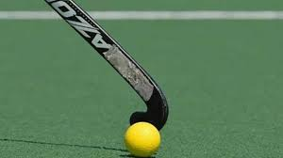 | Warm-up  Dribble  Receive and control  Jab tackle  Block tackle  Bridge  Push pass  Shoot | Defend  Positional play
 | Key Vocabulary
SAFETY
GRIP
FLAT-SIDE
BRIDGE
INVASION
PUSH PASS
BARRIER
ATTACKING
DEFENDING

