Learning Objectives | Skills
- Demonstrate good handling technique whilst running.  - Use the correct technique when handling the ball for passing/catching.  - Demonstrate good change of pace when catching and throwing the ball.  - Throw and catch using correct ‘W’ technique.  - Begin to apply dodging and evasion with the introduction of 2v1 play.  - Understand positions in the game and how they help with attacking and defending.  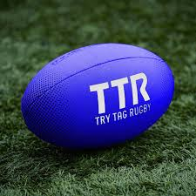  - Develop the use of spatial awareness and communication.  - Develop skills and ability to defend the ball from opponents.  - Develop the different methods of attack and defence of the ‘try’ line.  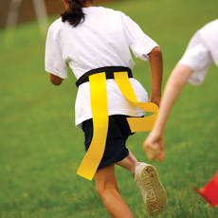 | Warm-up  Handling  ‘W-shape’ handling  Catch  Pocket pass  Evasion | Tagging  Tackle  Score  Attack  Defend  Interception
 | Key Vocabulary
 | Passing  Catching  Tagging  Forwards  Backwards  Sideways  Invasion | Try  Handling  Spatial awareness  Knock-On  Attacking  Defending

