Learning Objectives | Skills
- Understand the importance of moving to the ball.  - Practise throwing/feeding the ball high and low.  - Demonstrate the ability to catch the ball at the highest and lowest points.  - Introducing volleying shot, dig and underarm serve.  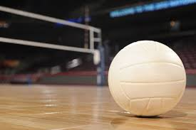 | Warm-up  Underarm serve  Pass  Volley  Catch  Throw | 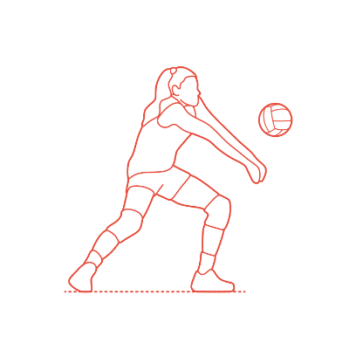  Forearm pass
 | Key Vocabulary
 | COURT  UNDERARM SERVE  FOREARM PASS  DIG | NET/WALL  VOLLEY  SET  FEED

