Year 2: The First Christians
Key Stories |  | Key Bible Passages |  | Key Vocabulary
The Beginning of the Church (Acts 2:42-47)  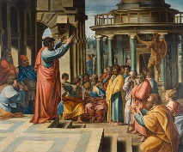  The Man Who Could Not Walk (Acts 3: 1-10)  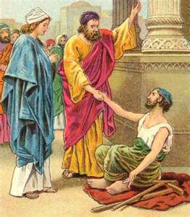  Peter in Prison (Acts 12: 1-19)  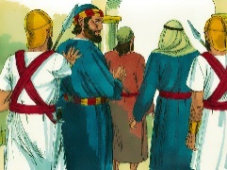  Peter Escapes (Acts 12: 1-19)  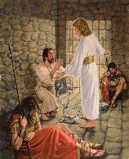 |  | Acts 2:42-47 |  | Pentecost  Promise  Apostles  Christians  Holy Spirit  Church
 |  | Acts 3: 1-10
 |  | Acts 12: 1-19
 |  | Key Colours
 |  | Green – Ordinary Time
 |  | White or Gold- Christmas and Easter
 |  | Red – Celebrations and feast days
 |  | Purple – Advent and Lent
 |  | Key Ideas |  | Key Figures/ People
 |  | To know how the Holy Spirit helped the Apostles.  Think of ways we can be like them. |  | Jesus
 |  | Know about the First Christians.  Think of ways we can be like them. |  | Peter
 |  | Know about how Jesus was able to help Peter and John.  Be aware that we can trust Jesus to help us. |  | John
Recall that the Holy Spirit was able to help the Apostles.
Be aware that the Holy Spirit helps us.
Know about Peter’s escape from prison.
Reflect on what we can learn from it.

