Year 6 Summer 2 Called to Serve
Key Stories | Key Bible Passages | Key Vocabulary
Gifts of the Holy Spirit  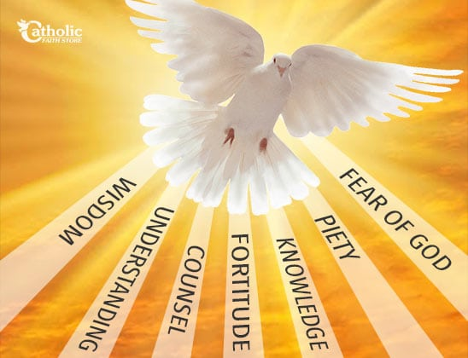  Annalena Tonelli  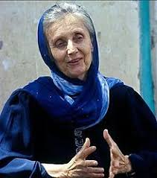 | Mark’s Gospel 1:7 6:31 8:34 10:44 13:33 14:32 16:15  Matt 20:28 “Not to be served but to serve.”  Nuptial Mass What happens during the sacrament of marriage.  Rite of the Sacrament of Holy Orders What happens when a priest is ordained | Unique  Mission  Service  Sacrament  Nuptial Blessing  Wisdom, understanding, knowledge, courage, reverence, right judgement, awe and wonder  Deacon  Priest  Bishop  Holy Orders
 | Key Colours
 | Green – Ordinary Time
 | White or Gold- Christmas and Easter
 | Red – Celebrations and feast days
 | Purple – Advent and Lent
 | Key Ideas | Key Figures/ People
 | - We are called to be disciples  - Understanding the sacrament of Confirmation and how we can use the gifts of the Holy Spirit  - Understand the sacrament of marriage  - Understand the sacrament of Holy Orders  - We can serve God in many ways by helping others  - People have responded to God’s call in a variety of ways. | Annalena Tonelli  Sr Joan Callaghan CP  Mama Maggie  Pauline Jaricot

