Year 2 Summer 1 2021
Learning objectives for this topic | Key vocabulary | Useful websites to search for
To listen to a variety of music on the theme friendship  To recognise and name some instruments – keyboards, drums, bass, electric guitars, singers.  To find the pulse of a piece of music.  To clap back rhythms.  To improvise – sing and play.  To identify pitch and changes in pitch.  To know how to warm up our voices  To sing in unison and solo. | Reggae music – a style of music that originated in Jamaica.  Pulse – the heartbeat of the music  Beat – another name for pulse  Rhythm – a repeated sequence of beats  Pitch – how high or low a sound is. This can be on a tuned instrument or with our voice.  Percussion – an un-tuned instrument used to accompany music.  Glockenspiel – a tuned instrument which is played by striking the metal bars with a beater. | BBC Learning Zone
Count on me – Bruno Mars
We Go Together (from Grease )
You Give A Little Love from Bugsy Malone
That's What Friends Are For by Gladys Knight
You've Got A Friend In Me by Randy Newman
Bugsy Malone
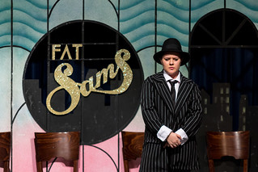

Toy Story
