Year 1 Summer 1 2021
Learning objectives for this topic | Key vocabulary | Useful websites to search for
To find the pulse/beat and understand that it is the heartbeat of the music.  To recognise and name two instruments they hear - singers, keyboards, bass, guitar, percussion.  To copy back rhythms heard.  To understand that pitch is high and low sounds.  To identify pitch in a song.  To begin to control voices and use pitch  To use instruments and play focusing on pitch.  To compose own music | Pulse – the heartbeat of the music  Beat – another name for pulse  Rhythm – a repeated sequence of beats  Pitch – how high or low a sound is. This can be on a tuned instrument or with our voice.  Percussion – an un-tuned instrument used to accompany music.  Glockenspiel – a tuned instrument which is played by striking the metal bars with a beater. | BBC Learning Zone
Music in the theme – imagination
Daydream Believer by The Monkees
Rainbow Connection from The Muppet Movie
A Whole New World from Aladdin
Supercalifragilisticexpialidocious from Mary Poppins
Pure Imagination from Willy Wonka & The Chocolate Factory
Mary Poppins

Willy Wonka
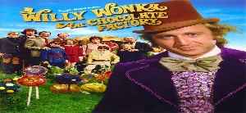
The Muppets
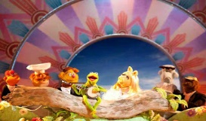
This Photo by Unknown Author is licensed under CC BY-NC-ND

