Year 3 Summer 1 Computing- Top Trumps Database
Learning objectives | Key vocabulary | Useful websites to search for
To understand the terminology around databases.  To compare paper and computerized databases.  To sort, filter and interpret data.  To represent data in different ways.  To sort data for a purpose. | Categorize Put into groups which have similar or the same properties  Data Information used for specific purpose.  Database For collecting and organising data stored on an electronics device.  Fields (data) Categories which information can be stored into.  Filter (data) Displays specified or selected data types.  Graphs and charts Visual methods of representing data.  Information Knowledge that can be remembered, written in documents or stored in different forms as data, such as in video files and audio recordings.  Record To log information in the present (for example data during a science experiment), to look back on it in the future.  Sort To arrange items by an order or into a category.  Spreadsheet A file where you can input, sort and analyse data across a series of cells. | - KS2 Computing BBC Bitesize  - The School Run KS2 Computing  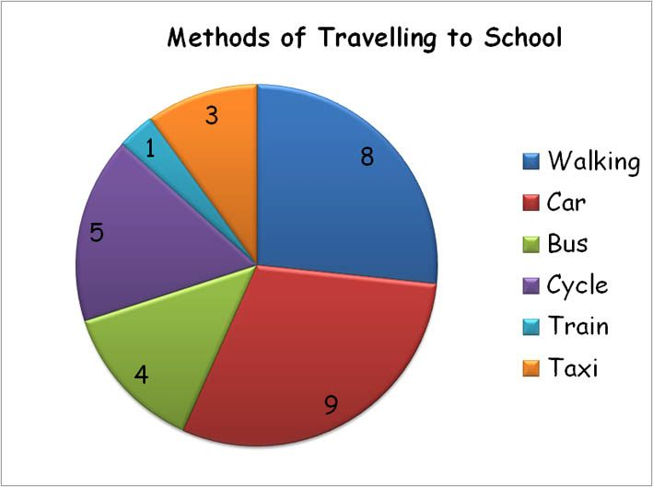
 |  | 