Year 6 Summer 1 Rivers and The Water Cycle
Learning objectives for this topic | Key vocabulary | Useful websites to search for
- To understand and explain the water cycle.  - To find out about rivers and how they erode, transport and deposit materials  - To find out why rivers are important.  - To find out about the causes of river pollution and the effect it has on the environment  - To investigate a river in detail including the effects on the environment and landscape | 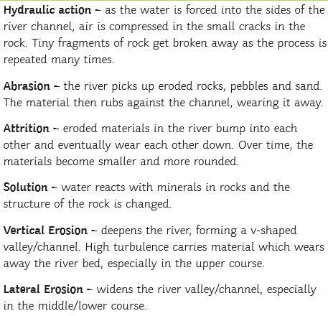  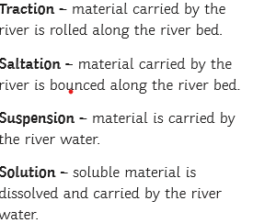  Erosion  Deposition  Rivers deposit eroded material when they lose speed  Transportation | http://www.fatbadgers.co.uk/Britain/rivers.htm  https://www.natgeokids.com/uk/?s=rivers&post_type=primary-resource  http://www.primaryhomeworkhelp.co.uk/rivers.html  https://www.bbc.co.uk/bitesize/clips/zb39jxs
