Year 5 Summer 1 Life in the Risen Jesus
Key Stories | Key Bible Passages | Key Vocabulary
The Resurrection  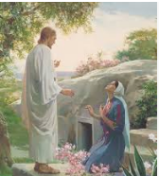  Appearance in Galilee  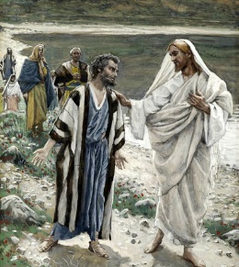  Pentecost  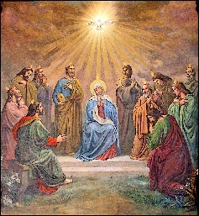  The Pharisee and the Tax Collector  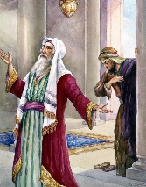 | Mark 16: 1-8 Jesus is Risen  Luke 24: 36-43 Jesus appears to His disciples  Matt 28: 20 “I am with you always, yes, to the end of time.”  Matt 6:5-13 Jesus teaches us to pray  Luke 18: 9-14 Parable of The Pharisee and the Tax collector | Sabbath, tabernacle, thanksgiving, meditation, contemplation, Rosary, mysteries, sorrowful, glorious
 | Key Colours
 | Green – Ordinary Time
 | White or Gold- Christmas and Easter
 | Red – Celebrations and feast days
 | Purple – Advent and Lent
 | Key Ideas | Key Figures/ People
 | - Jesus rose from the dead.  - Jesus is present in our lives in different way.  - It is important to make time for prayer each day.  - Belief in prayer helps shape people’s lives. | Mary Magdalene, Jesus,  Mary (Mother of Jesus),  