Learning Objectives | Key Vocabulary
- Differentiate between catching techniques by assessing the height of the ball.  - Move feet appropriately to prepare to hit the ball.  - Understand the appropriate throwing action (overarm/underarm) in a match situation.  - Recognise and attempt to replicate the correct bowling technique.  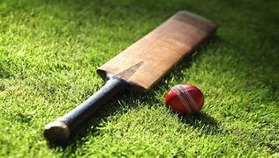  - Have the ability to hit the ball from both sides of the body. | - Batting  - Fielding  - Striking  - Wickets  - Bowling  - Target  - Retrieve  - Boundary | - Grip  - Stance  - Technique  - Hand-eye coordination  - Position  - Wide
 | Skills
- Catching
- Fielding
- Overarm bowling
- Throwing
- Combination batting
- Backswing
- Wicket keeping

