Year 2: Good News
Key Stories |  | Key Bible Passages |  | Key Vocabulary
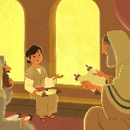  Jesus as a Little Boy  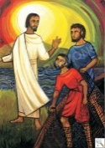  Jesus Chooses Disciples  The Ten Lepers  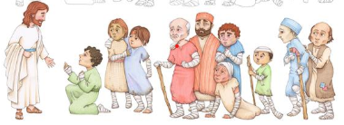  Feeding the 5000  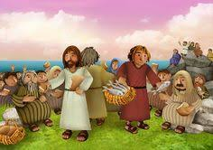  The Paralysed Man  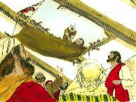 |  | Jesus Lost in the Temple - Luke 2:41–52 |  | Joy  Sadness  Miracle  Believe  Lepers  Leprosy  Heal  priests  Miracle  Loaves  Fish  Disciples
 |  | The First Disciples - Matthew 4:18–22
 |  | The Ten Lepers – Luke 17
 |  | Feeding the 5000 - Matthew 14:13-21
 |  | The Paralysed Man - Matthew 9:1–8
 |  | Key Colours
 |  | Green – Ordinary Time
 |  | White or Gold- Christmas and Easter
 |  | Red – Celebrations and feast days
 |  | Purple – Advent and Lent
 |  | Key Ideas |  | Key Figures/ People
 |  | Know about the Holy Family. Reflect on Jesus being young like us. |  | Jesus
 |  | Know that Jesus chose some helpers. Think about what we can learn from Simon Peter and Andrew. |  | Mary
 |  | Know the story of the Ten Lepers. Think about why it is important to say thank you. |  | Joseph
 |  | Know that Jesus worked a miracle to feed the hungry crowd. |  | Simon Peter and Andrew
 |  | Be aware that Jesus asks us to help others in need. |  | The Ten Lepers
 |  | Know that Jesus cured a man who was paralysed. |  | The Paralysed Man
 |  | Reflect on the great love that Jesus has for all who are sick.

