Year 2 Spring 2 Habitats
Learning objectives for this topic | Key vocabulary | Useful websites to search for
To know that most living things live in habitats to which they are suited.  To be able to describe how different habitats provide for the basic need of different kinds of plants and animals and know how they depend on each other.  To observe and describe the weather associated with different seasons and how day length varies.  To investigate which plants and birds can be observed in our locality at this time of year and identify and name them.  To make observational drawings of plants and animals in our locality.  To explore and compare the differences between things that are living, dead and never been alive.  To find out about and describe the basic needs of animals for survival (water, food and air).  To identify that most animals live in habitats to which they are suited.  To design a habitat to provide for the basic need s of birds in our local area.  To identify and name a variety of birds in their habitat, local to us. | Environment – all the physical features on earth, including everything living and non-living.  Habitat – the home of an animal or plant.  Weather – sunshine, rain, wind, storms or snow which can change daily depending on the season.  Seasons – four different times of year with different weather – summer, spring, autumn and winter.  Locality – the local area where you live.  Living organisms – everything living including, plants animals and insects.  Needs – to maintain life certain things are needed like air, food, warmth, water.  RSPB – Royal Society for the protection of birds. | Bbc.co.uk – bitesize KS1  RSPB.org.uk  National Geographic for kids
Biologist – person who studies living things
David Attenborough
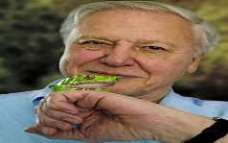
This Photo by Unknown Author is licensed under CC BY-NC-ND
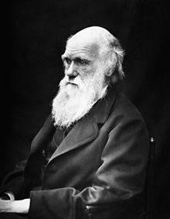Charles Darwin
 |  | Polar habitat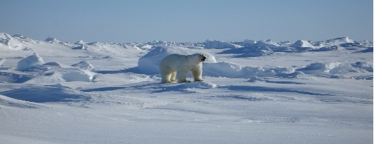
Hedgerow habitat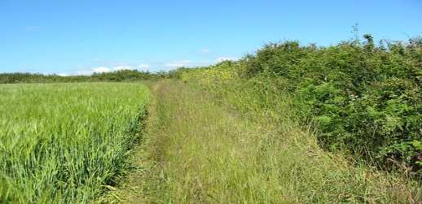
This Photo by Unknown Author is licensed under CC BY-SA

