Following Jesus
Key Stories |  | Key Bible Passages |  | Key Vocabulary
Jesus Chooses his disciples  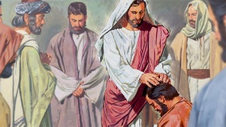  Jesus in the  Temple  The Good Samaritan  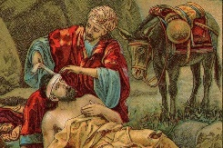  Jesus goes to Jerusalem  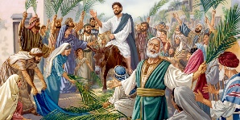  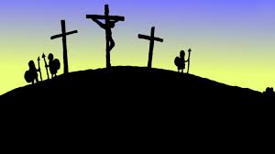  Good Friday |  | Lk::5:1-11 Jesus chooses his disciples  Lk. 11:1-4 Jesus teaches the disciples to pray  Lk.10:29-37 The Good Samaritan  Lk: 19:28-38 Jesus goes to Jerusalem  Mk.15 Good Friday |  | Disciples | Jesus
 |  | Key Colours |  | Love | Pray
 |  | Green – Ordinary Time |  | welcoming | Jerusalem
 |  | White or Gold- Christmas and Easter
 |  | Red – Celebrations and feast days
 |  | Purple – Advent and Lent
 |  | Key Ideas |  | Key Figures/ People
 |  | How do we choose are friends? |  | Jesus
 |  | How do we pray? |  | Disciples
 |  | Being a follower of Jesus |  | The Good Samaritan
 |  | How can we can show that we ‘welcome’ Jesus |  | Peter
 |  | Sad news turning into good news

