Mary Our Mother
Key Stories |  | Key Bible Passages |  | Key Vocabulary
The Annunciation  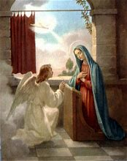  The birth of Jesus  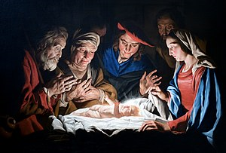 |  | Luke 1:26-28 |  | Annunciation  Jesus  Saviour | Mary Our Mother  Lord  Angel Gabriel
 |  | Luke 1:26-38
 |  | Luke 1:39-45
 |  | Matthew 2:2
 |  |  |  | Parish Priest | Mass
 |  | Key Colours
 |  | Green – Ordinary Time
 |  | White or Gold- Christmas and Easter
 |  | Red – Celebrations and feast days
 |  | Purple – Advent and Lent
 |  | Key Ideas |  | Key Figures/ People
 |  | Know that God chose Mary to be the mother of his son. |  | Angel Gabriel
 |  | Know that Mary answered God’s call and reflect on it.
 |  | Know that Mary went to visit her cousin Elizabeth. |  | Mary / Elizabeth
 |  | Know about the mystery of incarnation. |  | Jesus  The Angels  The shepherds  The Wise men  The Inn keeper
 |  | Understand that Advent is a time to prepare to celebrate the birth of Jesus.
 |  | Know about the birth of Jesus
 |  | To reflect on the birth of Jesus

