Year 3 Autumn 1 Art – Coastal scenes- based on the work of Maud Lewis
Learning objectives for this topic | Key vocabulary | Key artists
To take inspiration from an artist.  To investigate and analyse the work of a specific artist.  To investigate different painting techniques.  To apply our understanding of painting techniques to our work.  To apply our understanding of painting techniques to layer and apply fine detail to our work.  To complete paintings using a variety of media. | Pattern  Texture  Colour  Size  Shape  Design  Sequence  Background  Foreground  Perspective  Materials  Analyze  Tear  Cut  Arrange | Maud Lewis  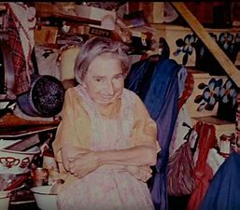  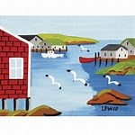  Maud Lewis’s Studio  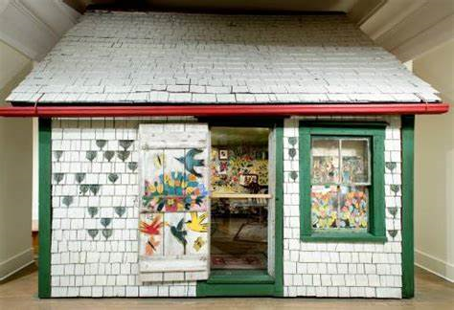
Art Skills Covered
Painting
Texture
Colour

Covering the elements of:
Texture, colour and shape. Tone, form and space

