Year 2 Spring 2 History
Learning objectives for this topic | Key vocabulary | Useful websites to search for
To identify Florence Nightingale and find out information on her life.  To identify Mary Seacole and find out information on her life.  To recognize similarities & differences between past & today.  To infer information from a written and/or visual account of a person’s life.  To know about primary & secondary sources.  To use still imagery to re-tell a life story further develop empathy.  To remember and recount events in chronological order.  To develop research methods.  To know about Victorian Britain.  To know simple facts about the Crimean war.  To know about the discovery of anti-biotics. | Florence Nightingale – first nurse from Victorian times.  Mary Seacole – a British-Jamaican lady who helped soldiers during the Crimean War.  Victorian Era – 1837 – 1901 when Queen Victoria was alive.  Crimean War – war between Britain, France & Turkey & Russia in 1853.  Chronological – events in time order.  Infection – disease or illness caused by germs either through passing on from one person to another or unclean conditions.  Military – soldiers who defend their country. | www.parkfieldict.co.uk/victorian/crimean  www.bbc.co.uk/history/interactive/timelines/british
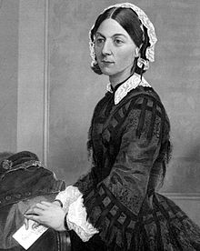
Florence Nightingale
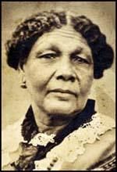
This Photo by Unknown Author is licensed under CC BY-SA-NC
Mary Seacole
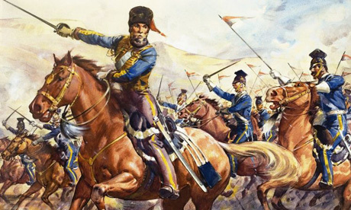
This Photo by Unknown Author is licensed under CC BY
Painting of the Charge of the Light Brigade.

