Art Knowledge Organiser: Cityscapes and Landscapes
Artists | What I am learning to do…
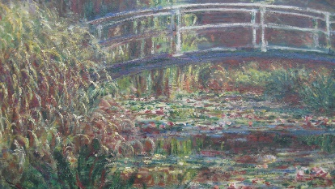  Monet  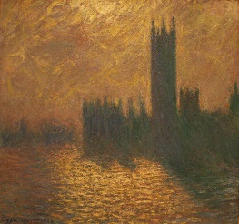  Van Gogh  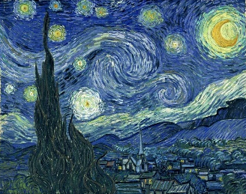  Metzinger  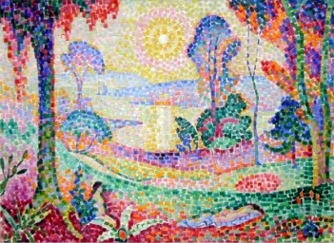 | I can use bright colours to paint a garden.  I can use pastels to create a colourful sky.  I can explain that Monet painted the same scene lots of times.  I can explain that Monet used colours to capture changing light.  I can use blue and yellow to paint the sky, the moon and stars.  I can explain that van Gogh painted pictures at different times of day.  I can colour squares in different colours to create features of a landscape.  I can make my landscape bright and colourful.  I can note one similarity and one difference between a Metzinger painting and a Monet painting.
Vocabulary | How have I done in this topic?
landscape  cityscape  scene  light  reflection,  smudge.  mosaic | √ √√ √√√

