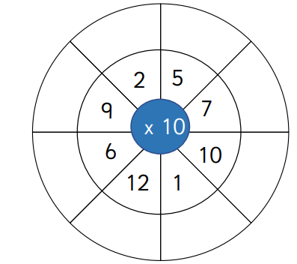
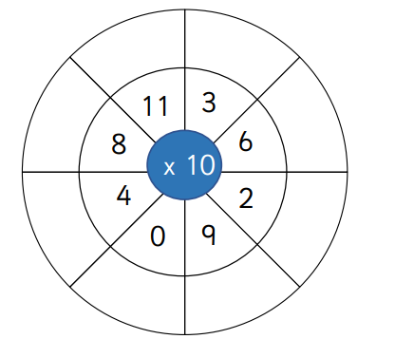
Can you complete these multiplication wheels – use your 100 square to help you count if you need to.
What number do all of these answers end in? ________________
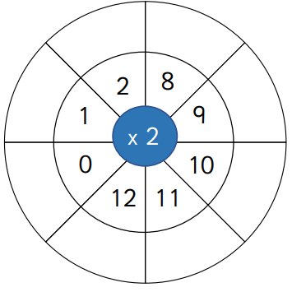
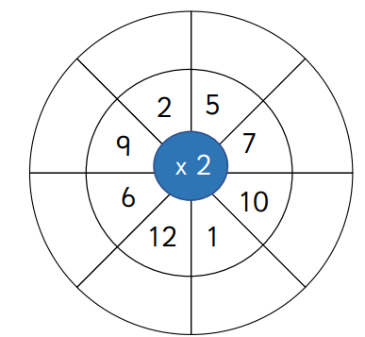

What numbers do all of these answers end in? ________________
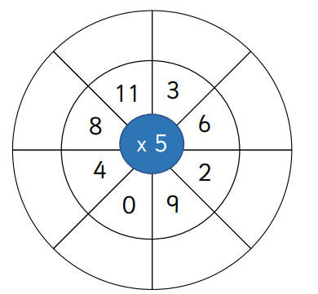

What numbers do all of these answers end in? ____________

