Our Vision

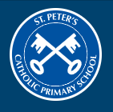

Throughout their time at St. Peter’s, our vision is to facilitate our children ‘to be the best that they can be.’
We offer an ambitious, rich, broad, balanced and differentiated curriculum which encourages pupils’ thirst for knowledge and their love of learning. Our curriculum is designed to facilitate all learners to develop the knowledge and cultural capital they need to succeed.
We have high ambitions for all our learners, and provide opportunities for children to achieve excellence in all areas of school life – each and every day.
St. Peter’s Catholic Primary School exists to develop the spiritual, academic, social, moral and physical development of the children entrusted to our care.

