 | Monday  Adult – Please could you start collecting any boxes/materials etc for the children to make their own chocolate factory on Wednesday | Tuesday | Wednesday
Activities for the last week | Charlie and the Chocolate factory  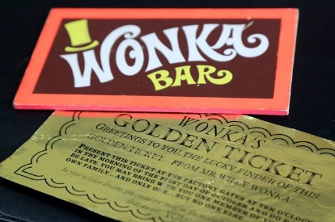  As it is the last week of school, I have organised some fun activities for you to do at home – it’s the same that the children are at school, so you can swap stories when you see each other!  We’ve been reading Charlie and the Chocolate factory at school and you’ve loved it.  Ask an adult and see if you are able to watch the video - I prefer the original one which is a bit older.  Over the next few days I have planned some fun activities around the story.  After watching the film, I would like you to write a little description about the characters using the worksheets to help you with the words. Think about what you liked about them, where they nice characters, what did they look like?  Remember your capital letters, full stops, finger spaces and beautiful handwriting.  Could you add an exclamation mark in their too?  If you finish this there is a word search that you could have a go at completing. | Sweet designer for the day!  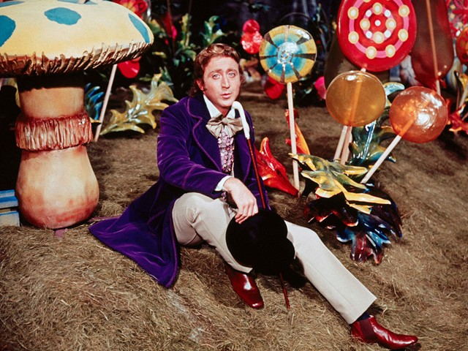  Today you are going to become a sweet designer just like Willy Wonka!  Can you think of a new sweet that you would like to create? It can have special powers like the ones in the story.  Think about what it would like it to look. What is it going to taste like?  After you have chosen your sweet or chocolate bar you can try designing your own wrapping for it.  Use lots of colour and make it nice and bright – you will want people to buy it remember! | Building your own chocolate factory.  Today you will need lots of different materials to build your own factory. See if you have any boxes, yogurt pots, toilet rolls etc…  I would like you to build your very own chocolate factory! However, the one in the story is a little boring and not very exciting to look at.  I would like you to make yours interesting and fun with lots of colour on it. You could put some sweet papers on the outside, or maybe even paint some dried pasta and put it on the outside.  Be creative and do whatever you would like!  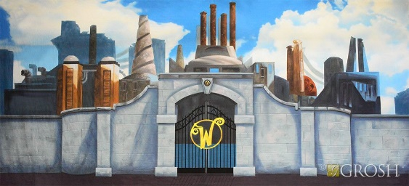  This might take you longer than today which is absolutely fine. It might keep you nice and busy for the rest of the week.  I’d love to see the end results if you would lie to send me some pictures of them?

