Hello everyone,
I hope you are all keeping safe and well. I just thought I would update you on what I have been doing.
Last time I wrote to you I was learning to crochet. Well I have had a good go at it and I can now make crochet flowers. I also made a baby blanket too for Mrs Cooks little baby!
I have been setting lovely learning jobs for my nursery children to do using videos, with Douglas dog helping me. He keeps jumping in on the videos!!
When we had the lovely sunshine, I managed to plant flowers and set up my water feature.
At the moment I am working in school with my little bubble of keyworker children from nursery and reception with Mrs Green. Let’s hope we can all get back to normal when it is safe for us all to be together.
I have missed all your smiley faces each day and hope that you continue to stay safe and well at home.
Mrs Walker
Here are some pictures of the things I’ve been doing.
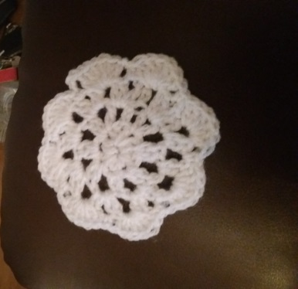
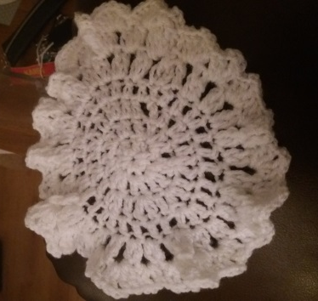
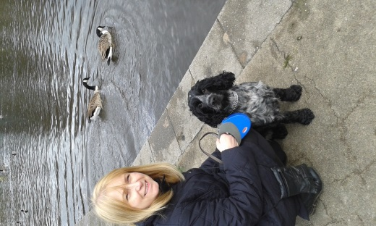

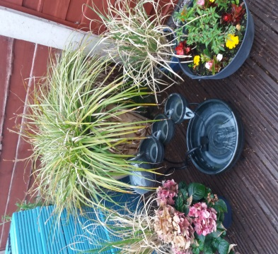
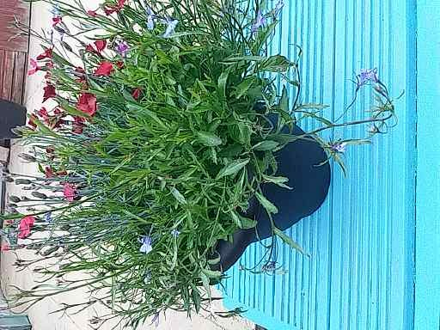
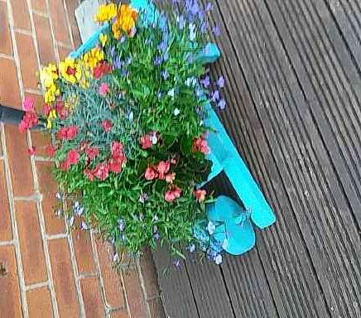
Douglas Dog

