Hello to all our wonderful children at St. Peter’s! Just like all the other teachers, I am missing you very much. School is not the same without the hustle and bustle of all of you being here. I am very much looking forward to the time when we can all get back together to make up our wonderful community here in school once again.
It has been lovely to see the photographs that you have sent to homelearning@st-peters.tameside.sch.uk. I have also really enjoyed looking at our St. Peter’s Twitter feed – the Hughes, Swanick and Figgins-Barratt families have been extremely busy contributing to this, which is great to see.
Even though I may not be able to see you until September, I would love to hear from you. I would also like you to know that I am keeping all of you very much in my thoughts and prayers. Please do let me know if there is anything special you would like me to pray for. We carry on holding Collective Worship each day in school, and have just this week remembered the feast of Corpus Christi – the body and blood of Christ. Some of you may remember how impressed the RE inspectors were this time last year, when they observed St. Peter’s children celebrating Corpus Christi through Collective Worship.
Please remember that whatever you are doing, and wherever you are, I am very proud of you. School is only a phone call, an Email or a Tweet away – please do keep in touch.
I also thought I would share with you some photographs of what my family have been up to during lockdown.
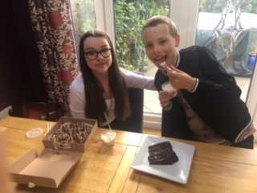 Here are my two children, Phoebe and Jack, enjoying a Saturday night treat from Sweet Diner in Denton.
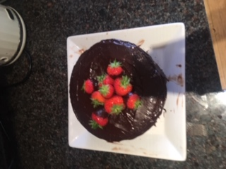This was a chocolate fudge cake which Phoebe made herself. It was absolutely delicious, but I think I need to have a word with her about making sure the plate is clean before she photographs her cooking creations!
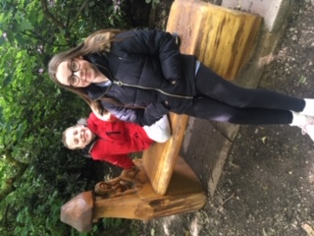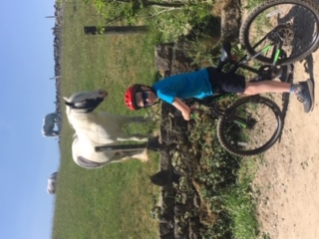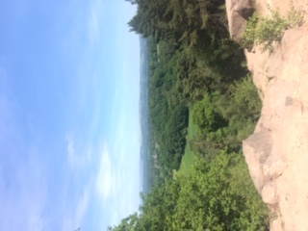
Here are photos of us on our daily walks. In these photos, we were visiting Hollingworth Lake, Alderley Edge and Towneley Park, which is in Burnley. I am originally from Burnley, and it was lovely to take Phoebe and Jack there to see their grandparents once we were all allowed to visit other people outdoors.
Take care, all of you, and keep on being the best that you can be.
All my love,
Mrs Ryan

