Hello everyone.
I hope you are all safe and well and still enjoy the time you are sharing with your families. I know these strange times have been going on for a while now but remember it’s to make sure we are all safe and hopefully we will all be back together really really soon.
Last time I spoke to you I was working at home, but I’m back in school now with some of your friends. I’m working in my usual classroom of Year 2 but it looks a little different to how you might remember it. I’m working with my good friend Mrs Broadbent and we are working with some of the nursery and reception children. We are working hard but also having lots of fun together.
When I have not been in school, I have been helping Jacob and Millie with all their home-schooling work, I hope you are all still working hard with your home schooling.
I have also spent lots of time in my garden, digging things up and planting lots of new plants.
Millie and I also like to get out and about on walks and see what wildlife we can spot.
And now we are allowed to go a little further Me, Mr Edge, Jacob and Millie went to the Lake District for the day to check out the boats.
I hope you all stay safe, well and most importantly happy.
I can’t wait to have you all back in school soon and to see all you lovely smiling faces.
Look after yourselves and all your grown-ups.
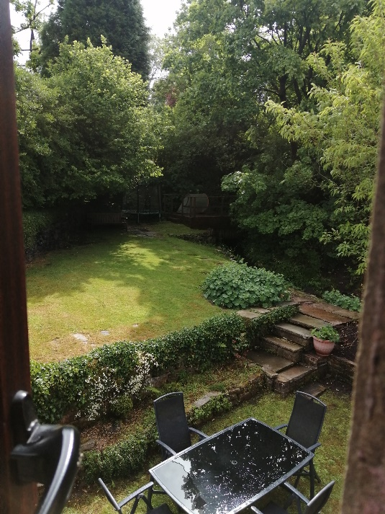
Love Mrs Edge.
