Hello Year 4,

I hope you’re all well and taking great care of each other. It seems like a very long time since I’ve seen most of you. I was very hopeful that we’d all be together again before the summer holidays but unfortunately, for the minute at least, it doesn’t look like that’s going to happen. I’m looking forward to working with you all next year though and for school to be full of your happy faces once again! I’m sure we’ll have a great time.

It’s still very different in school but it’s nice being back in class working with a group of children. I hope you’re all managing to complete some of the home learning that’s being set. Just doing a little will make that transition back into school that little bit easier when that day finally comes. Please send in some photos to Year4@st-peters.tameside.sch.uk if you’re happy to share them and have them added to the website. It’s always great to see what you’re all up to or if you just want to send me a note to say hello it would be great to hear from you.

I hope as well as some home learning you’ve been keeping yourselves busy in lots of interesting ways. Nate and Ava have been doing lots of arts and crafts at home and I’m often met with a new creation when I get back from work. They’ve also been working hard on their gardening skills planting seeds. Their plants are growing very well and hopefully we’ll have some nice vegetables to use in our cooking. Nate and I have been investigating magnets with his magnet set and firing his new rocket which has led to me searching through the hedge on quite a few occasions in order to retrieve them. They’ve both been having fun with the paddling pool and Nate has been helping me fix the brakes on the car and in return I’ve been helping him build his Lego.

That’s all from me for now. Keep looking after your families everyone and enjoy this time you have together and I look forward to hearing about all the things you’ve been doing and new skills you’ve learnt to keep yourselves busy when I see you all again.

Stay safe and well.

God bless,
Mr Gould

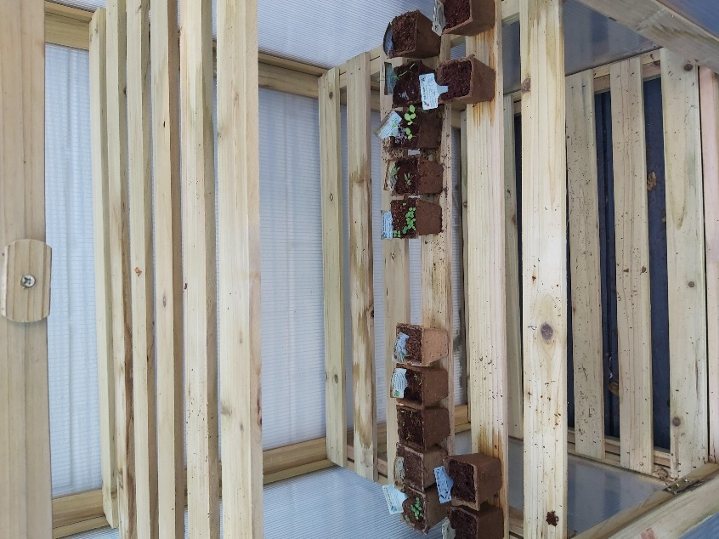
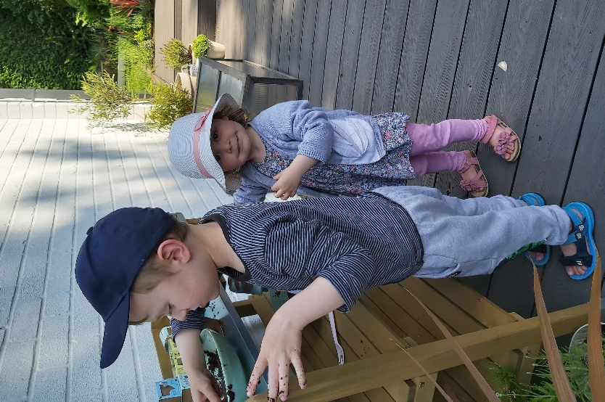

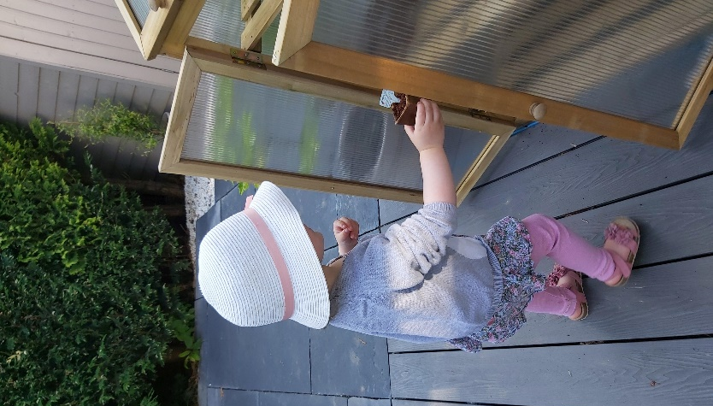

Nate and Ava have been busy planting their seeds. The first batch are growing well.

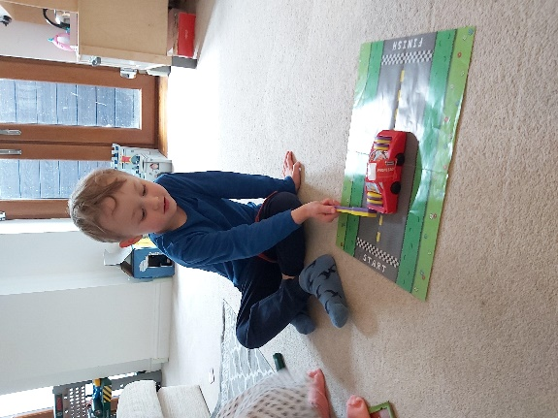
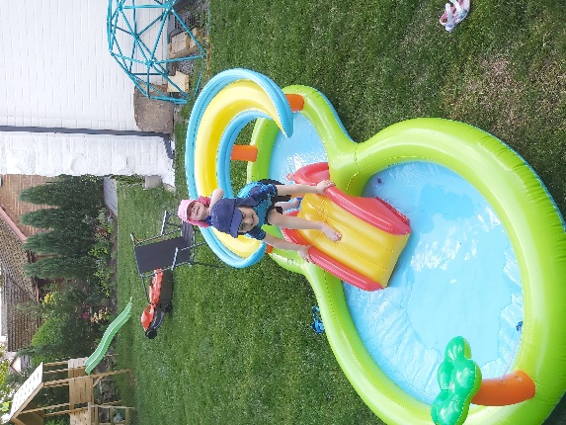
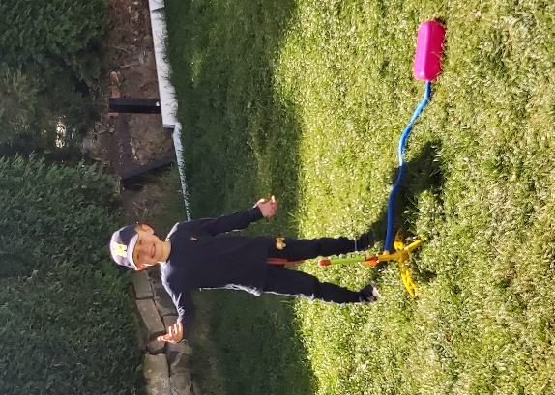

Nate’s carried out lots of investigations with his magnet set. He’s loved launching his air powered rocket. We haven’t been able to fire it too high because we don’t want it to land in the neighbours’ gardens. As soon as we can Nate’s going to go to his grandad’s farm where there’s a bit more space. Nate and Ava have loved getting the paddling pool out whenever it’s been sunny. I’ve not loved blowing it up!
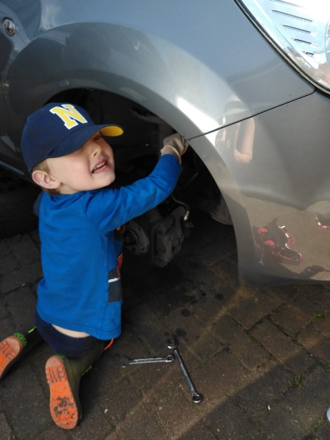
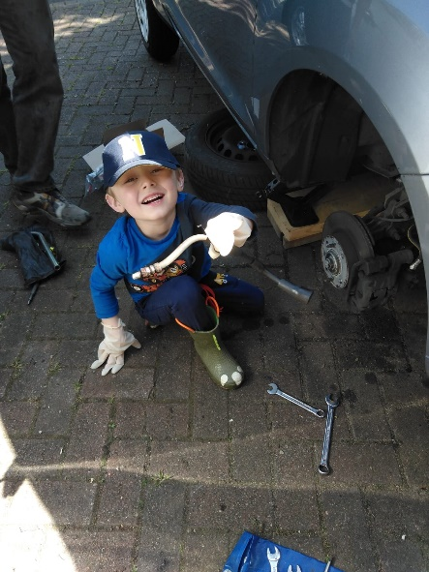
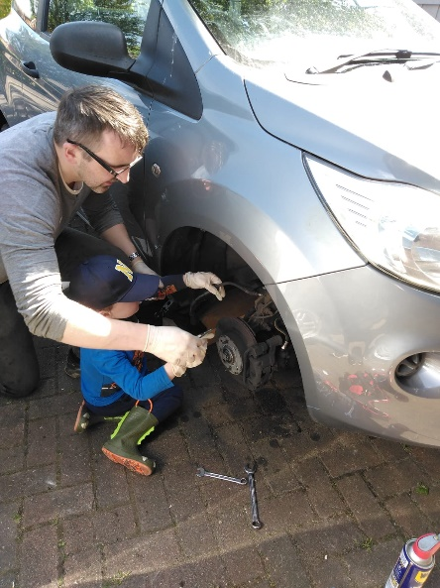

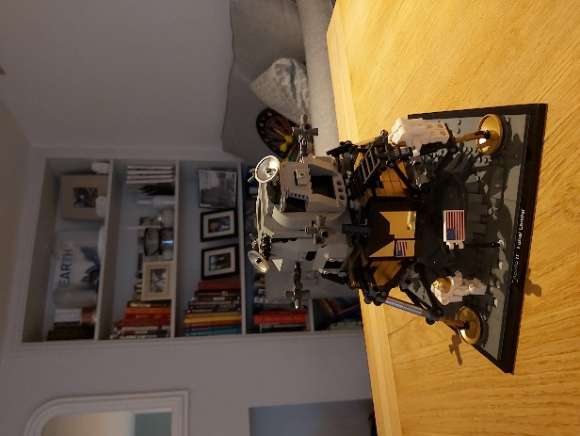
Nate was a great help giving me a hand to replace the brake hoses on the car. He did charge me for his time though and he made me help build his Lego in return!

