History

What was the Blitz in WWII?

<https://www.youtube.com/watch?v=Fte9DpZRfwo>

Look at the power point that discusses what people used to protect themselves during the war. This has been loaded on the school website.

Then test your knowledge by completing work sheet 3B and 3C.

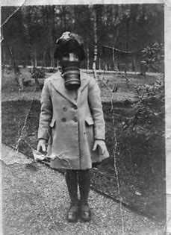

English

See separate sheet

Spellings for w/c 22.06.20

Here is this week’s spelling list. Challenge yourself to a spelling test.

science, obey, eight, scientist, freight, to, two, too, meat, meet

Grammar and Punctuation

This week we are going to look at different spellings, punctuation and grammar completing a different activity every day.

Science- Plants

How is the water transported through the stem?

How do nutrients come through roots?

Look at <http://www.mbgnet.net/bioplants/parts.html>

Use the animation on ‘Making food’ page to see how amazing plants are because they are able to make their own food. They use chlorophyll (special green chemical) in their leaves, light, water and carbon dioxide (gas). The process is called photosynthesis. Chlorophyll takes in some of the energy in sunlight. The plant uses energy to make sugar from carbon dioxide and water. It turns sugar into starch. Photosynthesis produces oxygen (gas) which animals need. Plants also take some nutrients from the soil.

Listen to The photosynthesis song- <https://www.youtube.com/watch?v=C1_uez5WX1o> to help you remember what happens. Now complete the Photosynthesis sheet.

Maths **Number**

**Main Activity Vocabulary**

**Add, addition equals 3-digits, hundreds, tens and units.**

**Angle, right-angle, acute angle, obtuse angle**

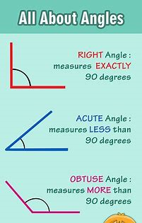

**Please work through each day on the Hamilton Trust. Maths- Year 3- week 13**

Remember test your knowledge and revise some of your number facts on Numbots and TT Rockstars.

R.E. Being a Christian

This week we are looking at prayer and we are going to answer the key questions. Read about prayer then answer these questions. Part 1

How do we pray?

Is there only one way to pray?

Why do we pray?

What is the importance of prayer?

Watch the power-point on

<https://www.twinkl.co.uk/resource/ni2-re-1-the-ten-lepers-powerpoint>

Now answer the questions on the sheet called Prayer.

Handwriting

This week your words are science, two and obey. Write them neatly in your handwriting books. Three lines of each. word.

D&T- This week I would like you to construct an Air Raid Shelter from WW11 using the templet from twinkl. Which I have loaded onto the school website.

Year 3 Home Learning 29th June 2020

Here is an overview of tasks we’d like your children to be completing over the next week. We are committed to ensuring your child is still learning as much as possible. Thank you for your support. Mrs Warran and Mrs Mc Wiggan

Daily Reading – Remember to read your reading books and your favourite books from home too! Also look at [www.booksfortopics.com/year-3](http://www.booksfortopics.com/year-3)