 | Monday | Tuesday | Wednesday | Thursday | Friday
Maths  3D Shapes | What is the different between a 2D and 3D shape?  What is the difference between a 2D shape and 3D shape?  This week we are looking at 3D shapes.  Look at this power point to remind yourself of the 3D shapes that we have looked at before.  https://www.twinkl.co.uk/ resource/t-n-928-every-day-3d- shapes-powerpoint  Today we’re going to remind ourselves of the different names of 3D shapes.  Colour the 2D and 3D shapes.  https://www.twinkl.co.uk/resource/t-n-694-2d-and-3d-shapes-colouring-sheets | Identify cubes and cuboids  Today we are focusing on a cube and cuboid. What is the difference, see if you can explain to a grown up! Can you answer that question using the words faces, edges and vertices?  A little clue – A vertex is a corner on a shape.  Now todays lesson I would like you to do a bit of an investigation. Hunt around your house and see how many cubes you can find and how many cuboids you can find. Remember that they are different shapes! | What is sphere?  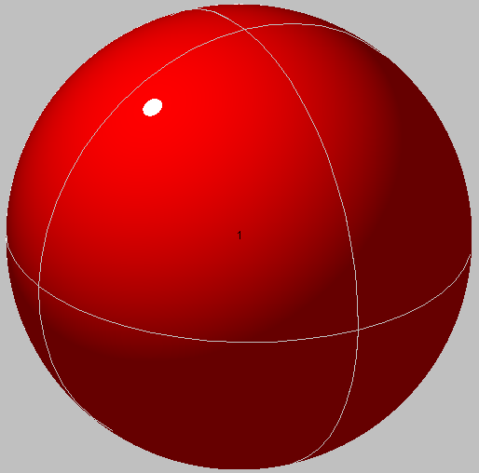  What shape is this? How do you know? How many edges does it have? How many sides does it have? How many vertices does it have?  Sphere Hunt  Ask a grown up to time you. You have 2 mins to find as many spheres in your house as you can – GO!  Now complete the sphere questions  https://www.twinkl.co.uk/ resource/ sphere-shape-activity-sheet-activity-sheet-t-n-7285 | What is a prism and a pyramid?  These two shapes are quite similar  Print of put the shapes below.  Cut them out and stick them together – like we done at school.  You may need a little help with this from a grown.  Have look and count how faces they both have, how many vertices they have and how many edges they have.  https://www.twinkl.co.uk/resource/t2-h-022-egyptians-pyramid-net  https://www.twinkl.co.uk/resource/t-n-2241-3d-net-for-triangular-prism | Today we are going to see how much you have learnt this week  Task 1  3D SHAPE HUNT  https://www.twinkl.co.uk/ resource/t-n-2995-3d-shape-hunt-worksheet  Task 2  Have a go and see if you can write down all the properties for all of these 3D shapes.  How many faces?  How many edges?  How many vertices?  https://www.twinkl.co.uk/resource/t-n-1040-3d-shape-properties-worksheets
English | Picture plot  Remind yourself of the new story we are looking at.  This is the video of it  https://www.youtube.com/watch?v=Led_flo3Efs  This is a power point in case you don’t want to watch the video.  https://www.twinkl.com.au/resource/au-t2-h-36-why-the-koala-has-a-stumpy-tail-powerpoint  Today you are going to draw a picture plot of what happens. This will help when write your own story. Use the template and draw pictures in each box to show what is happening.  Remember you have a new character instead of the kangaroo that you did last week.  Think about the beginning – introduce where the two characters are and what do they decide to do?  Middle - what excuses does the koala bear give so he doesn’t have to help (think of two).  End – what does the kangaroo/ your new character do? How does it end?  Challenge  Write a sentence for each box on another piece of paper. You don’t need to write too much here, just a short sentence NOT THE WHOLE STORY.  Reading each day  Phonics practise | Beginning of the story  Are we ready to start writing our story today?  We are only to write the beginning though. We always do this in school and write a little bit each day, We do this so each part is your best story writing with all the things we need to put in.  Read the story that I have written – you may need a little help. I have spilt in up into 3 parts – beginning, middle and end.  Now read the beginning part again and underline any good adjectives, any joining words like and, because. Underline how I start the story. Are there any other words that you really like?  Today I would like you write the beginning part of your story, only to the part I have. Think about all the great words that you have underlined. Can you put them into your story?  Don’t forget capital letters and full stops, finger spaces and beautiful handwriting.  Try and use ‘and’ ‘because in there.  Try and add a couple of adjectives.  Keep reading through what you have written (out loud) so you know it makes sense.  Reading each day  Phonics practise | Middle of the story  Read what you wrote yesterday. I hope you’re really proud of it!  Today we are going to write the middle part of the story today.  Just like did yesterday read the middle part of my story.  Underline any good adjectives, any joining words like and, because.  Have I used any questions?  Now write the middle of your story, only to the part I have. What do they decide to do? What are the excuses that Koala gives so he doesn’t have to help?  Don’t forget capital letters and full stops, finger spaces and beautiful handwriting.  Try and use ‘and’ in there to join two sentences.  Challenge yourself to write a question with the correct punctuation.  Keep reading through what you have written (out loud) so you know it makes sense.  Reading each day  Phonics practise | End of the story  We are now at the end of your story. I hope you have enjoyed story writing this week!  Yes, today we are going to write the end of the story.  Just like did yesterday read the ending of my story.  Underline any good adjectives, any joining words like and, because. Look at how I have ended the story.  Now it’s your turn to write your own.  What does your new character do? Remember the Koala must still lose his tail!  Don’t forget capital letters and full stops, finger spaces and beautiful handwriting.  Try and use ‘and’ in there to join two sentences.  Challenge yourself to write a question with the correct punctuation.  Keep reading through what you have written (out loud) so you know it makes sense.  Reading each day Phonics practise | Comprehension  Today I would like you to complete the comprehension questions.  I’m hoping this won’t be too tricky as you have all worked so hard on the story this week.  Use my story to answer the questions.  Reading each day  Phonics practise
Science- For any day of the week | Our science topic is The Farm/animals.  How do animals move?  For science this week, have a think how different animals move. We use our legs to walk. What does a bird use to move? Or even a snake?  Look at the power point. See if you can about how these animals move. Do they have legs? Do they have wings?  Today I would like you to sort the different animals into the correct box.
RE - For any day of the week | Our topic in RE in The Resurrection  .  First have a think about how you would feel if you met someone in a place where you did not expect to see them.  Did you recognise them right away?  What helped you to recognise them?  Why do you think you did not recognise them straight away?  Today we are looking are how Jesus helped the disciples to understand that he was alive and how excited they were! Now read the story.  Remember that the door was locked, and Jesus still appeared. They thought they were seeing a ghost!  Read though these questions and see if you can talk about them with a grown up.  - Why do you think the disciples thought Jesus was seeing a ghost?  - What did Jesus do to help them understand he was real and alive?  - Why do you think Jesus wanted his friends to know he was real?  - How do you think the disciples felt when they knew it was Jesus?  What questions do you think they would ask him? Fill in the speech bubbles with questions that the disciples might have asked Jesus. You can then colour in the people to look like a disciple too.
Geography/ Art - For any day of the week | Our geography topic is Australia this half term.  What is the great Barrier reef?  Today we are going to be looking at the Great Barrier Reef Australia. I have included a lovely video for you to watch to get some fact about it! If you want you could do a little bit of research about it on a computer with the help of a grown up.  https://www.youtube.com/watch?v=61RzwbaSoeU  Think about where it is, what lives there, how big it is?  Now I would like you to draw a beautiful picture of it. Remember all the lovely creatures you would find. Make sure it is nice and colourful and you can label the different things you have put in it. If you have some arts and crafts at home maybe you could add different materials on it too!  As part of your art this week you could paint a lovely picture of the Great barrier Reef. Trying mixing some colours together to make some unusual colours.

