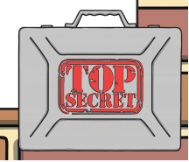
Year 2’s Secret Mission

Year 2, your grown-ups have been working incredibly hard and it is time for them to have a reward. Your secret mission should you choose to accept it is the following:

- You must make a thank you card for your grown-ups (without them seeing) and hide it somewhere for them to find.
- You must do at least one piece of work each day without any fuss and make your grown-ups say one of the following words: wow, amazing, great, super, fantastic or wonderful!
- You must get your grown-up to email Mrs Russell to say that you have completed your secret mission.

If your house has happy grown-ups by the end of the week, you will receive your secret agent certificate. You will then be ready for future challenges. This will be tough Year 2 but I know you can do it.
Good luck!

