The Ascension

Jesus knew that he would soon have to return to his Father in Heaven. He couldn’t stay on Earth forever to help his disciples. Instead Jesus told them that he would send the Holy Spirit to be with them.
Jesus told his disciples that the Holy Spirit would help them remember his teachings. It would help them understand what he had been telling them in his parables and why he had performed his miracles so that they could tell others.
Jesus told the disciples to go back to Jerusalem, stay in the city and wait for the Holy Spirit to come to them. He told them that when they received the Holy Spirit, they would be his witnesses throughout the whole world.
After he had spoken to them Jesus took them out of the city. He lifted up his hands and blessed them. While the disciples watched, Jesus was taken up into the air and a cloud hid him from their sight.
The apostles returned to Jerusalem where they were joined by Mary and several other women. They locked themselves in the upper room and the prayed continuously.

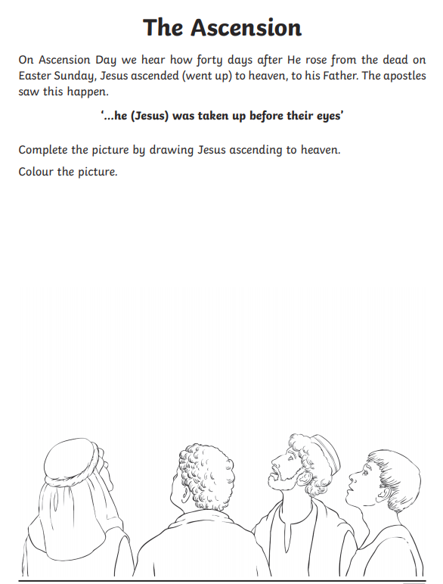

Add the disciples’ thoughts to the thought bubbles about what they are witnessing

