L.O. Identify human and physical features in our local area of Stalybridge.
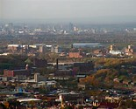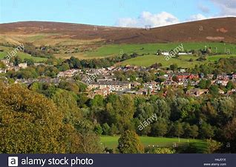
Physical Features | Human Features

