Doubting Thomas
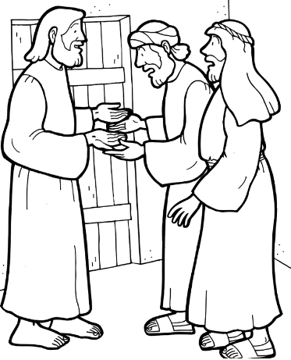
Part 1. Jesus Appears to Thomas
Now Thomas, one of the Twelve, was not with the disciples when Jesus came. So, the other disciples told him, “We have seen the Lord!”
But he said to them, “Unless I see the nail marks in his hands and put my finger where the nails were, and put my hand into his side, I will not believe.”
A week later his disciples were in the house again, and Thomas was with them. Though the doors were locked, Jesus came and stood among them and said, “Peace be with you!” Then he said to Thomas, “Put your finger here; see my hands. Reach out your hand and put it into my side. Stop doubting and believe.”
Thomas said to him, “My Lord and my God!”
Then Jesus told him, “Because you have seen me, you have believed; blessed are those who have not seen and yet have believed.”
Now complete the thought bubble as to why you believe it was right or wrong for Thomas to doubt Jesus, explain your reasons why.

Part 2.
Imagine that you are a reporter for the ‘Jerusalem Times’ and that they have been sent to interview Thomas about his experience. Write some questions to ask Thomas, then hot seat an adult (they can pretend to be Thomas) and you can ask them your questions.

